**Control Systems Combination**

**Lab report #04**



Fall 2022

CSE-310L Control Systems

Submitted by: **Ashfaq Ahmad**

Registration No: **19PWCSE1795**

Class Section: **B**

“On my honor, as student of University of Engineering and Technology, I have neither given nor received unauthorized assistance on this academic work.”

Student Signature: ______________

Submitted to:

**Dr: Muniba Ashfaq**

**Oct** 28, 2022

**Department of Computer Systems Engineering**

**University of Engineering and Technology, Peshawar**

**System Combination:**

* Connecting two or more systems in particular pattern is called system combination.

**Three types of combinations**

1. **Series Combination:**

Connecting two or more system in series is called is called series combination.

1. **Parallel Combination:**

Connecting two or more system in Parallel is called is called series combination.

1. **Complex Combination:**

Combination of systems which is neither in series form nor in parallel form.

**Task 01:**

Connect the following three systems in series and then find its equivalent system.

1. Sys1=1/x+1
2. Sys2=1/x+3
3. Sys3=x+3/x+5

**Block Diagram of series Combination:**

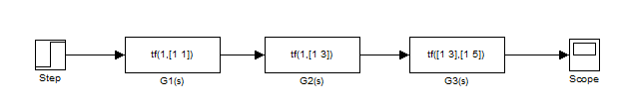

**Step response:**

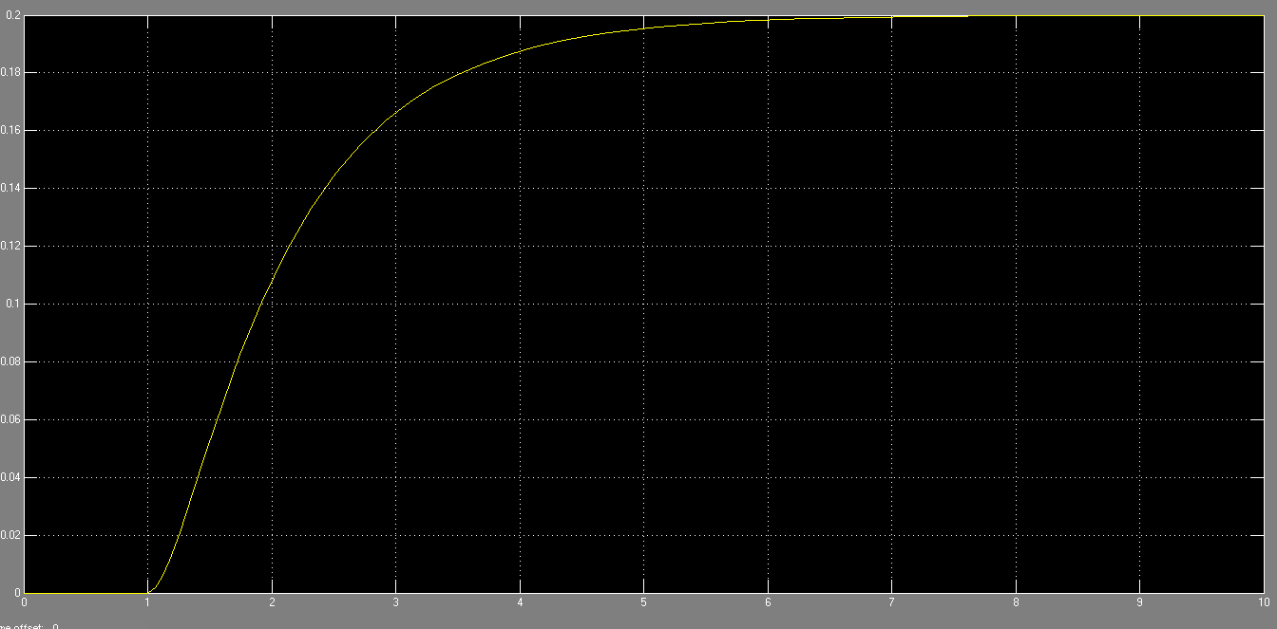

**Series Combination through Coding:**

clc

clear all

close all

n1=1;

d1=[1 1];

sys1=tf(n1,d1);

n2=1;

d2=[1 3];

sys2=tf(n2,d2);

n3=[1 3];

d3=[1 5];

sys3=tf(n3,d3);

series1=series(sys1,sys2);

series_equivalent=series(series1,sys3)

**Step Response:**



**Equivalent system:**

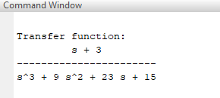

**Block Diagram of equivalent system:**

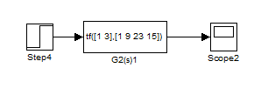

**Step response:**

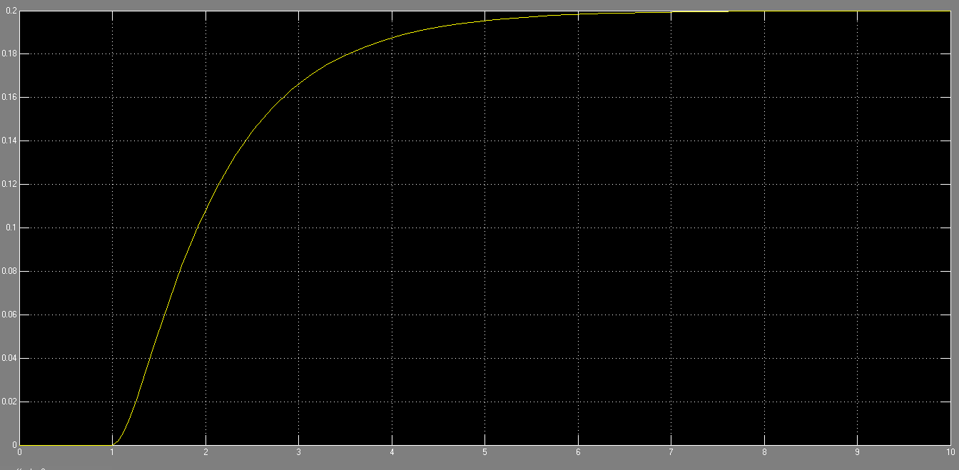

**Task 02:**

Connect the following three systems in Parallel and then find its equivalent system.

1. Sys1=1/x+1
2. Sys2=1/x+3
3. Sys3=x+3/x+5

**Block Diagram of parallel Combination:**

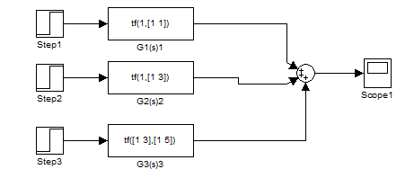

**Step response:**

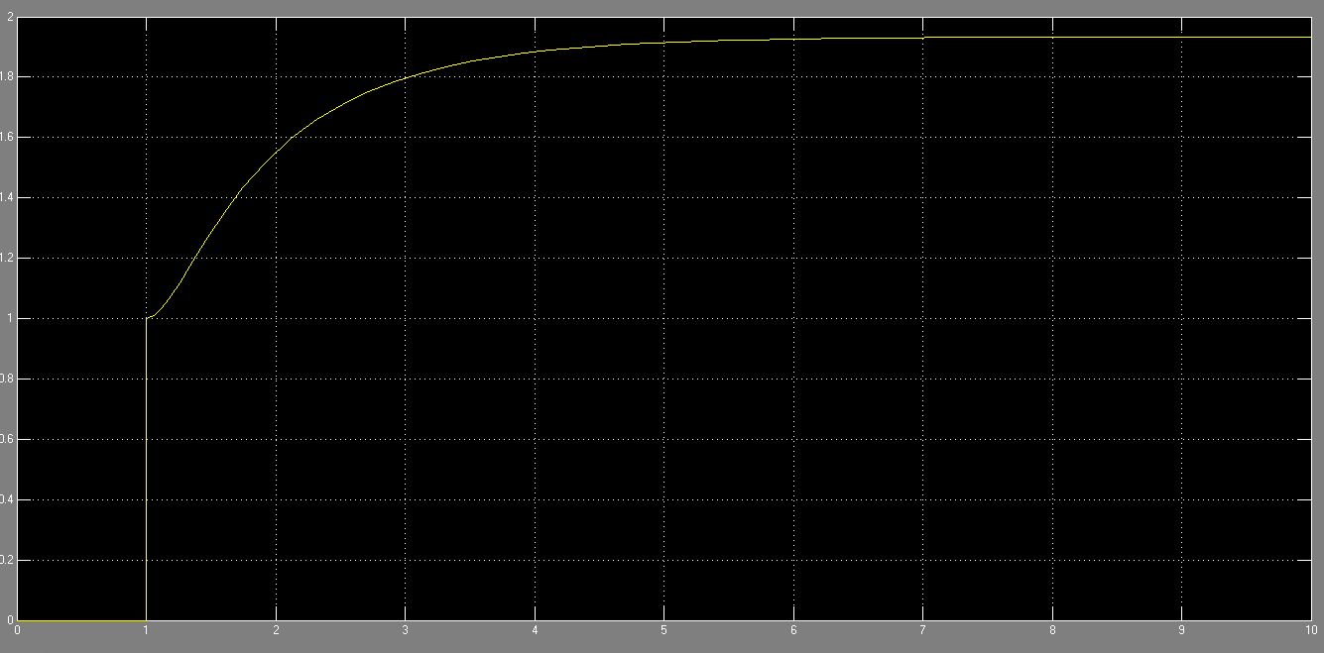

**Parallel Combination through Coding:**

clc

clear all

close all

n1=1;

d1=[1 1];

sys1=tf(n1,d1);

n2=1;

d2=[1 3];

sys2=tf(n2,d2);

n3=[1 3];

d3=[1 5];

sys3=tf(n3,d3);

P1=parallel(sys1,sys2);

Parallel_equivalent=parallel(P1,sys3)

step_response=step(Parallel_equivalent);

plot(step_response);

**Step response:**



**Equivalent system:**

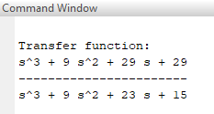

**Block Diagram of equivalent system:**

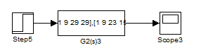

**Step response:**

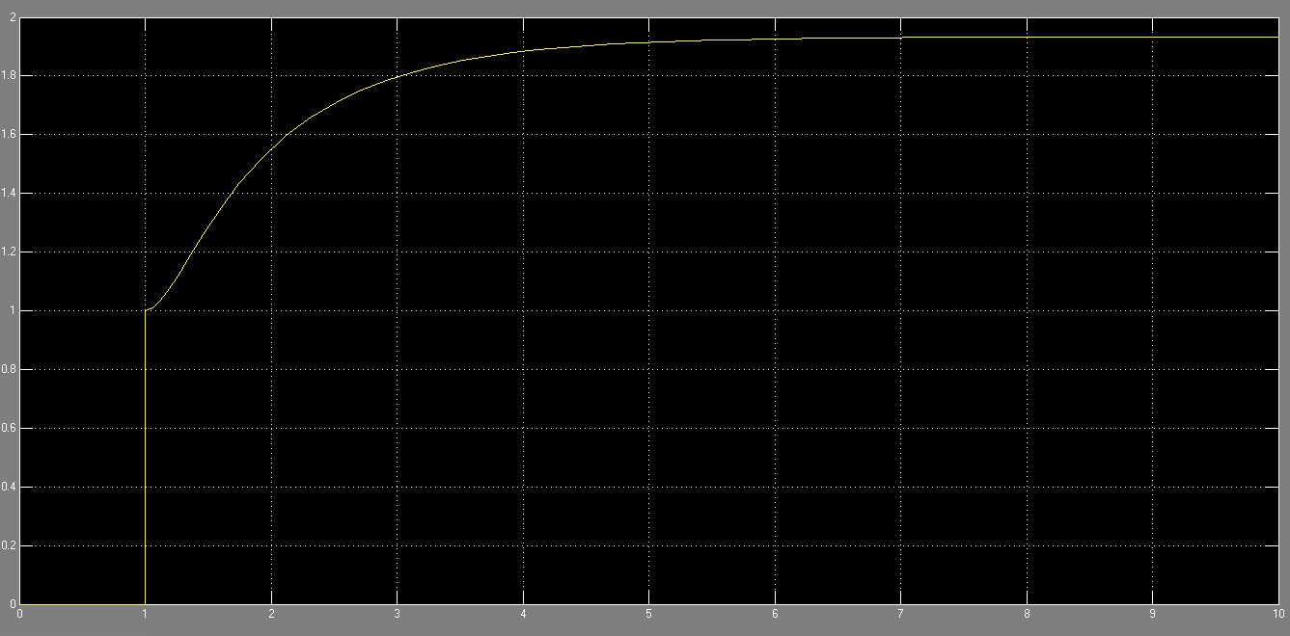

**Task 03:**

Connect the following three systems in Complex form.

1. Sys1=1/x+1
2. Sys2=1/x+3
3. Sys3=x+3/x+5

**Block Diagram of Complex Combination:**

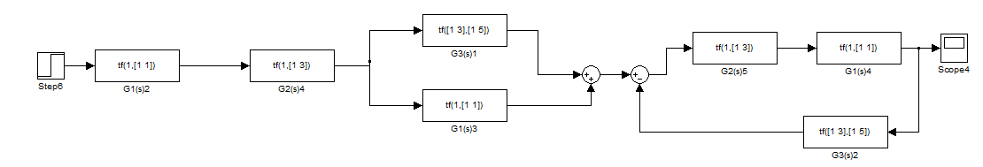

**Step response:**

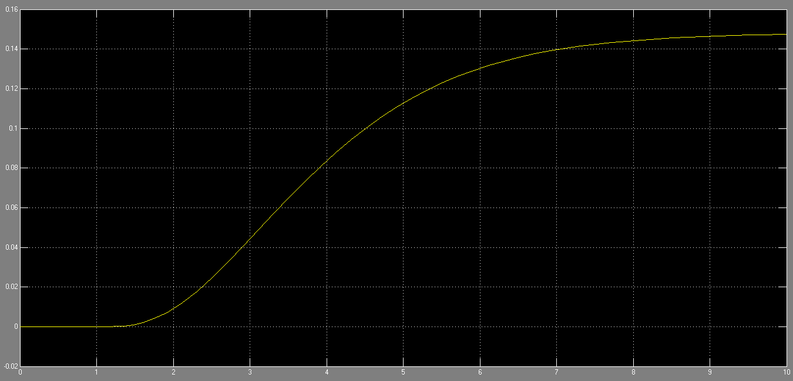

**Complex Combination through Coding:**

clc

clear all

close all

t=0:0.01:10;

n1=1;

d1=[1 1];

sys1=tf(n1,d1);

n2=1;

d2=[1 3];

sys2=tf(n2,d2);

n3=[1 3];

d3=[1 5];

sys3=tf(n3,d3);

series1=series(sys1,sys2);

P1=parallel(sys1,sys3);

series2=series(series1,P1);

fb=feedback(series1,sys3);

finalseries=series(fb,series1)

step_response=step(finalseries);

plot(step_response);

**Step response:**



**Equivalent system:**

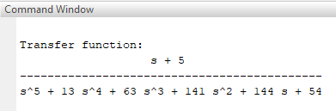

**Block Diagram of equivalent system:**

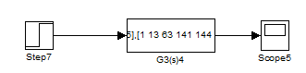

**Step response:**

